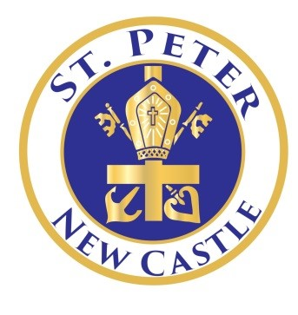
May 2020

We continue to pray for a quick end to this pandemic as well as healing and comfort to all those who are suffering from it.

Below are some important updates:

- Bishop Malooly will conduct a Catholic School Mass on Wednesday, May 13, at 10 a.m. Go to www.youtube.com/DioceseofWilm. Everyone is invited.

- Diocesan financial aid decisions for 2020-2021 will be announced in mid-May.

- Tuition payments should continue to be paid to the school. The school has contractual commitments for salaries, insurance, and license fees that continue through this time. If you need to make a payment, please contact Mr. Zitz about paying online with a credit card or arranging payment drop off.

- The Fallen Heroes 5K Run/Walk scheduled for mid-May will be rescheduled when we return to school.

- Student pictures taken on March 13 will be delivered after we return to school. Barksdale, located in Pennsylvania, was deemed a non-essential business, so they have remained closed during the pandemic.

- If you ordered a yearbook, please contact Mr. Zitz at zitz@stpeternewcastle.org to arrange for pick up.

